Correction TP 4

Interface

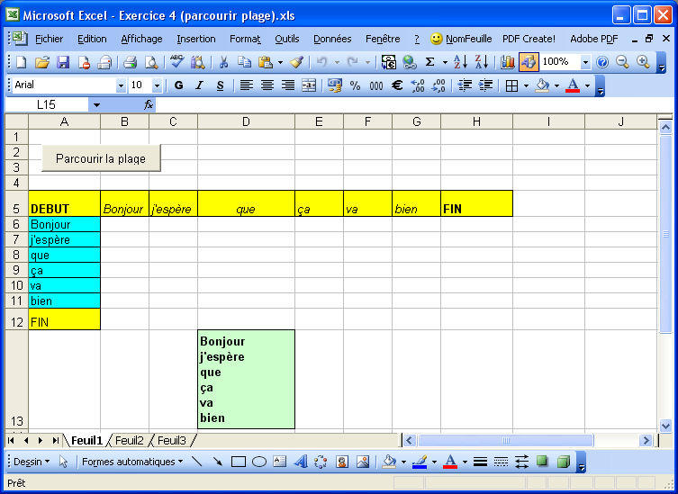

Code

Private Sub BtonParcourir_Click()
Dim i As Byte
Dim Phrase As String
Range("A5:H5").Select
For i = 2 To Selection.Count
Phrase = Phrase & Cells(5, i).Value & Chr$(10)
Cells(4 + i, 1).Value = Cells(5, i).Value
Next i
Phrase = Mid(Phrase, 1, Len(Phrase) - 5)
Range("D13").Select
With Selection
.Value = Phrase
.Font.Bold = True
.Interior.ColorIndex = 35
End With
End Sub

